**1.Create a P-T-S VPN and attach a VM to it**

> to create a point to site VPN connection we need to create a Virtual network Gateway

* A virtual network Gateway is configured

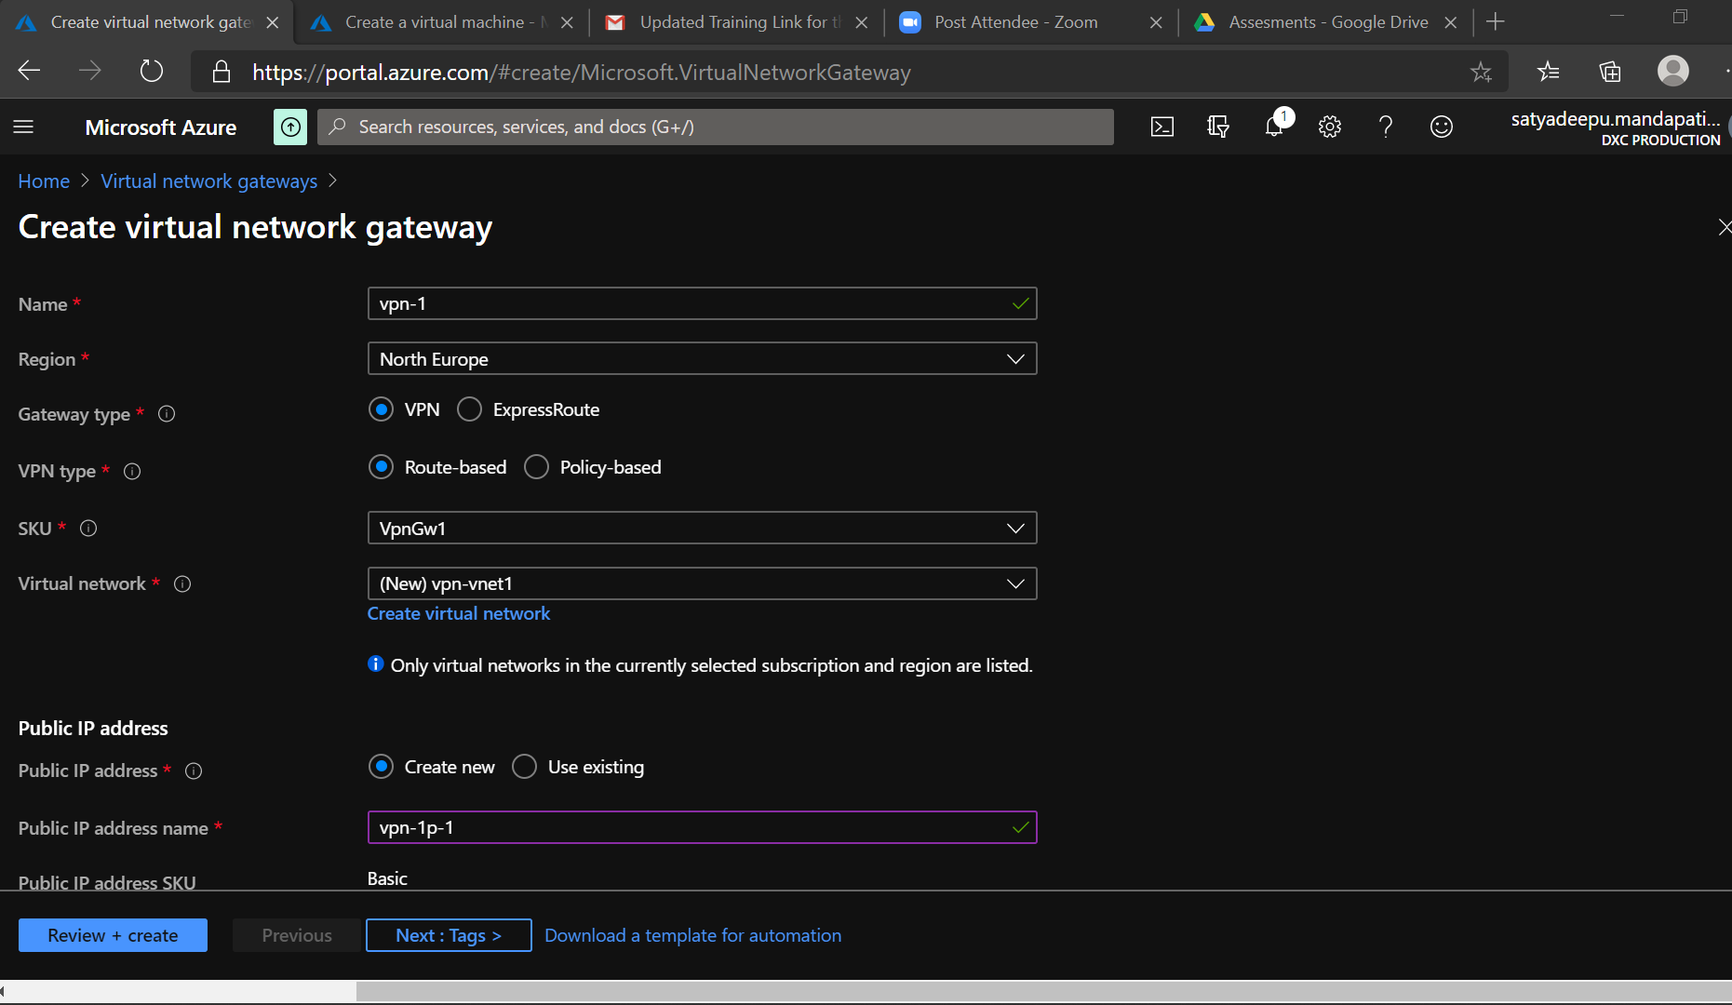

* VPN certificates Configurations

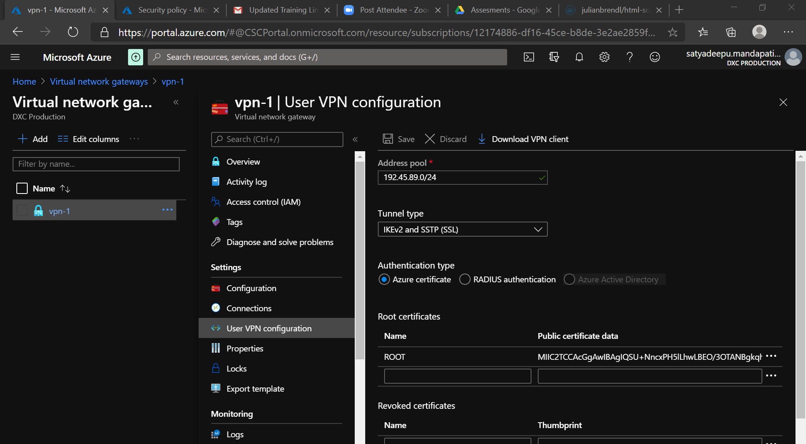

* Connecting to VPN Client in the local host

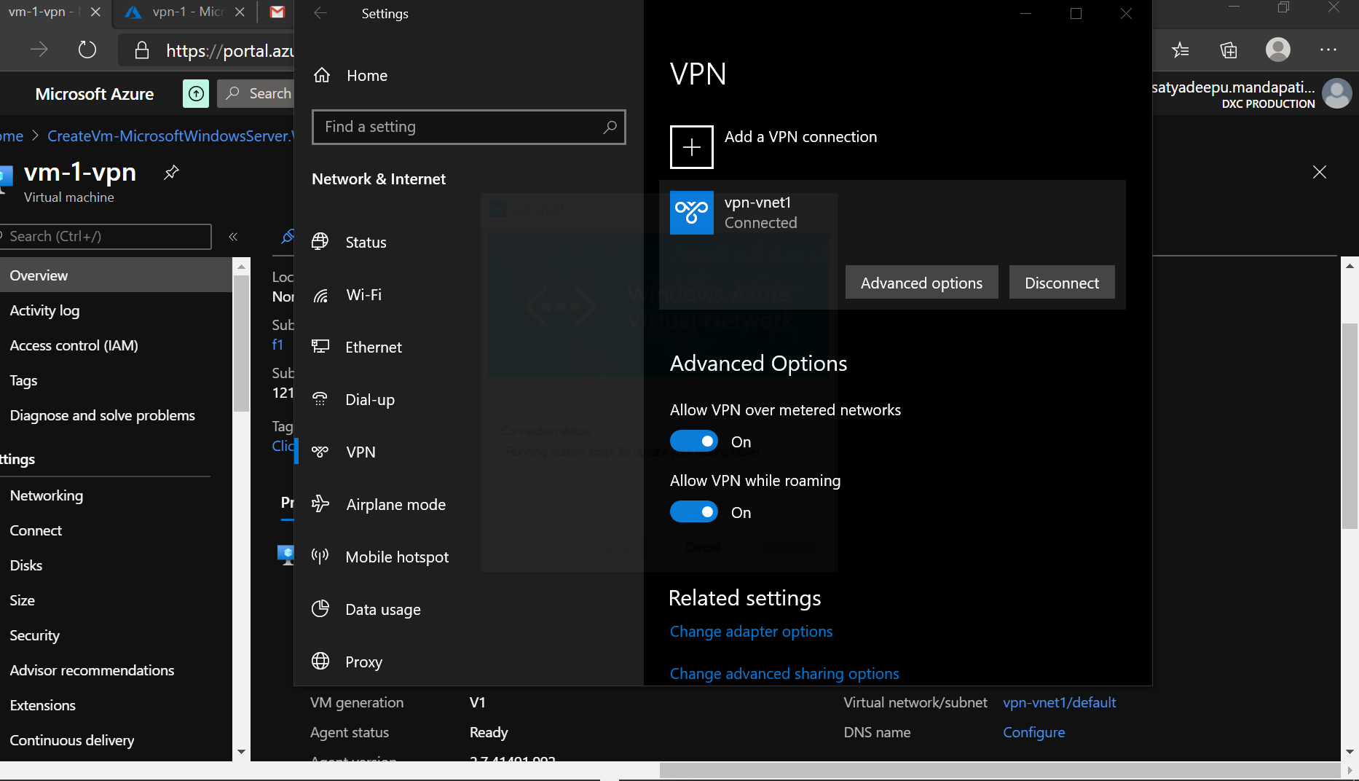

* A virtual machine is attached to vnet

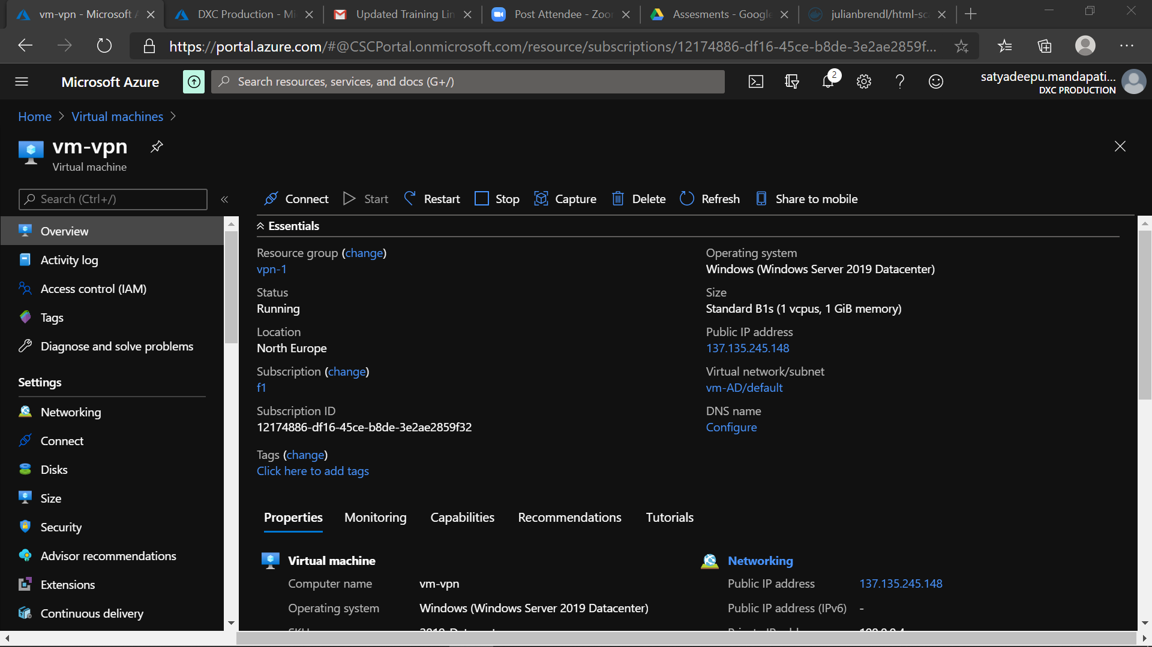

* Connecting to Vm using Private IP Address(205.232.0.4) By VPN Gate way

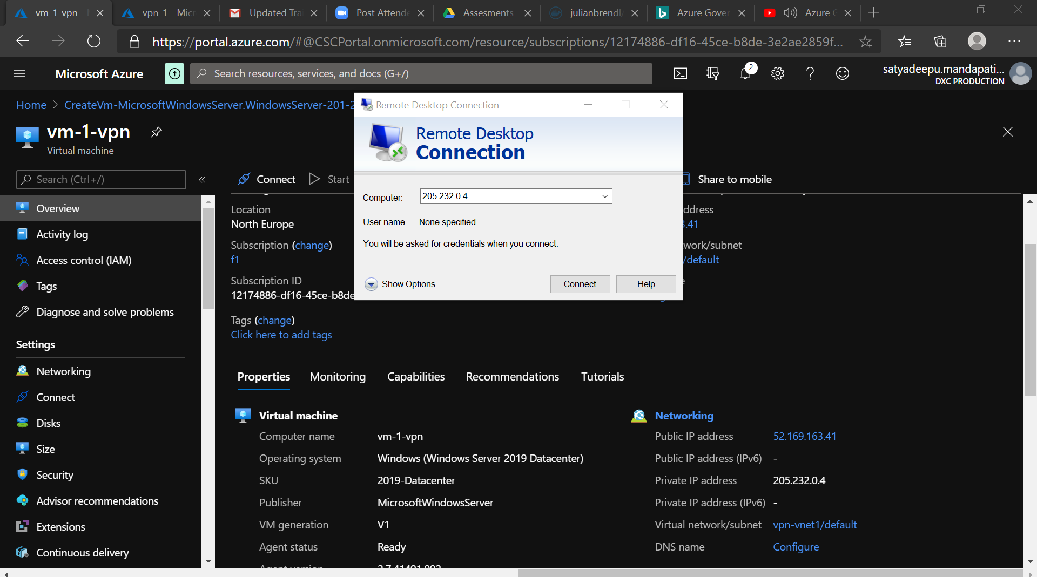

**2.create a two web application in west us and central Us then attach to the traffic manager with Priority routing method**

* Two web apps are created in **central us** and b **west us**  regions

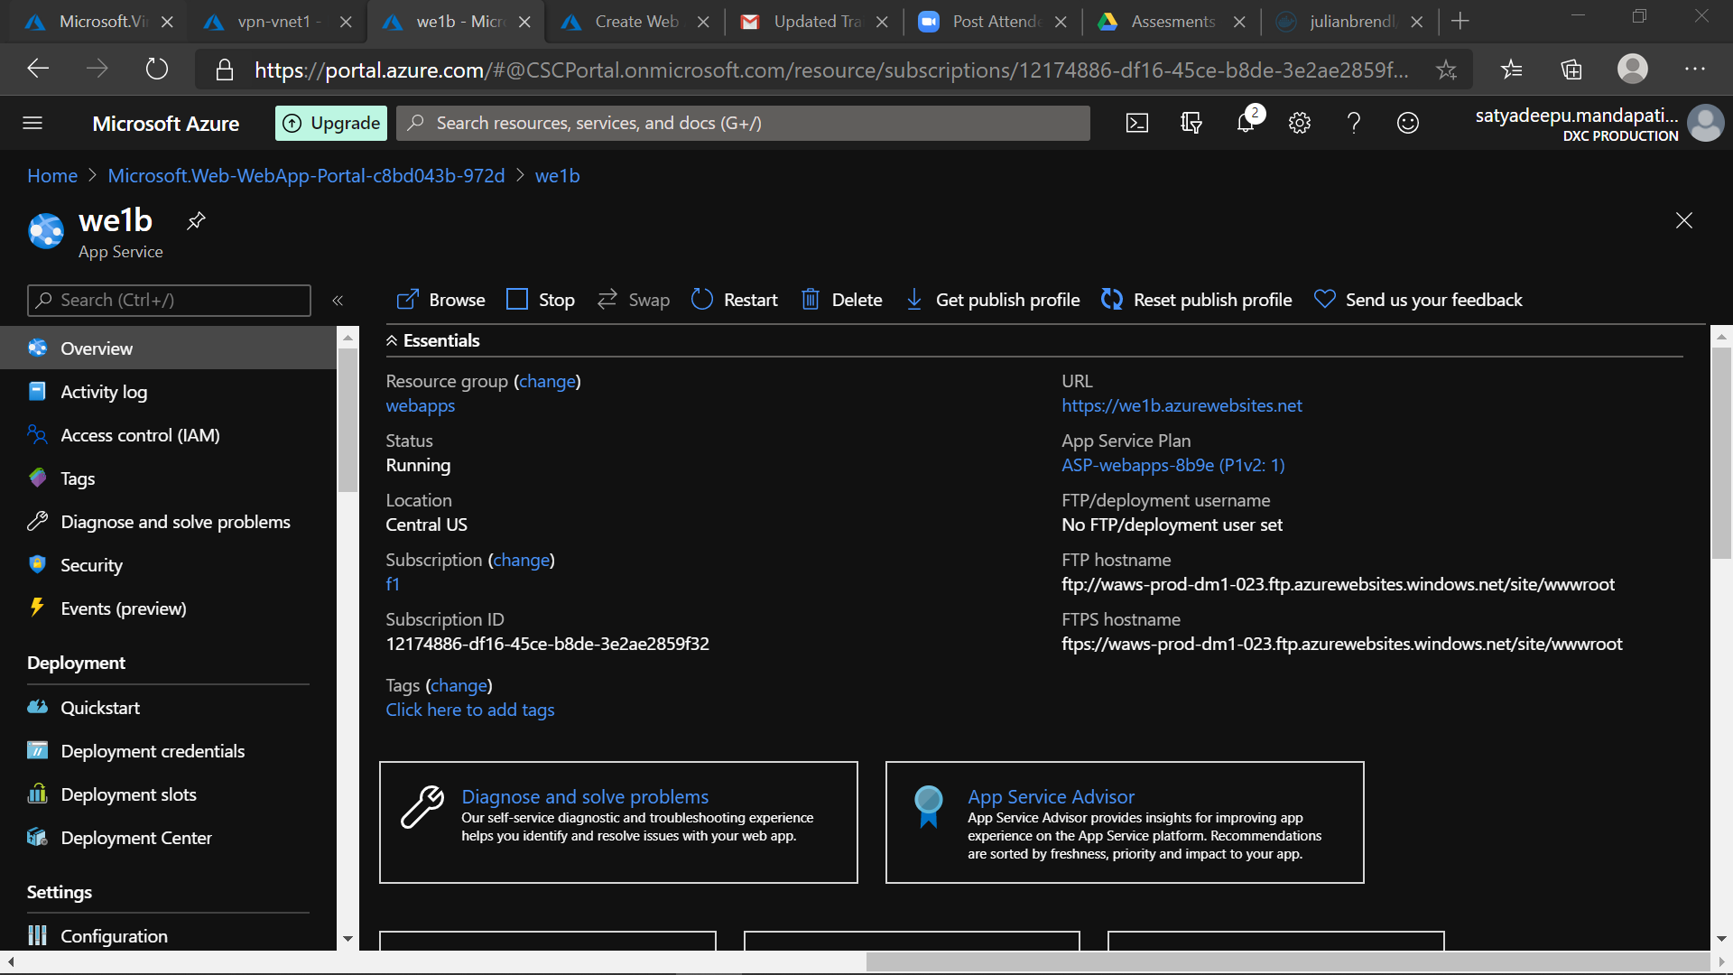

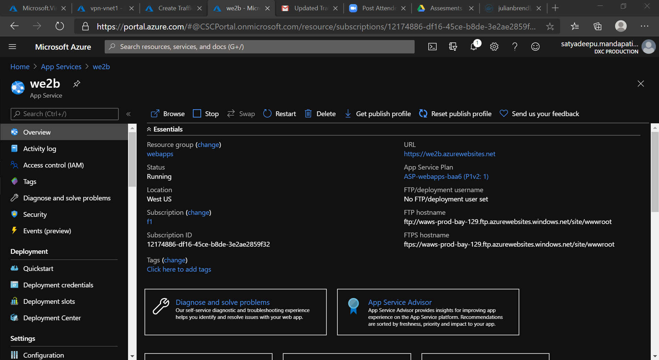

* To route the traffic by means of **priority routing**  we need a traffic manager profile
* **Traffic manager** with two Traffic end points is configured for the Two web Apps
* The **Priority Routing** Method is configured in the traffic manager

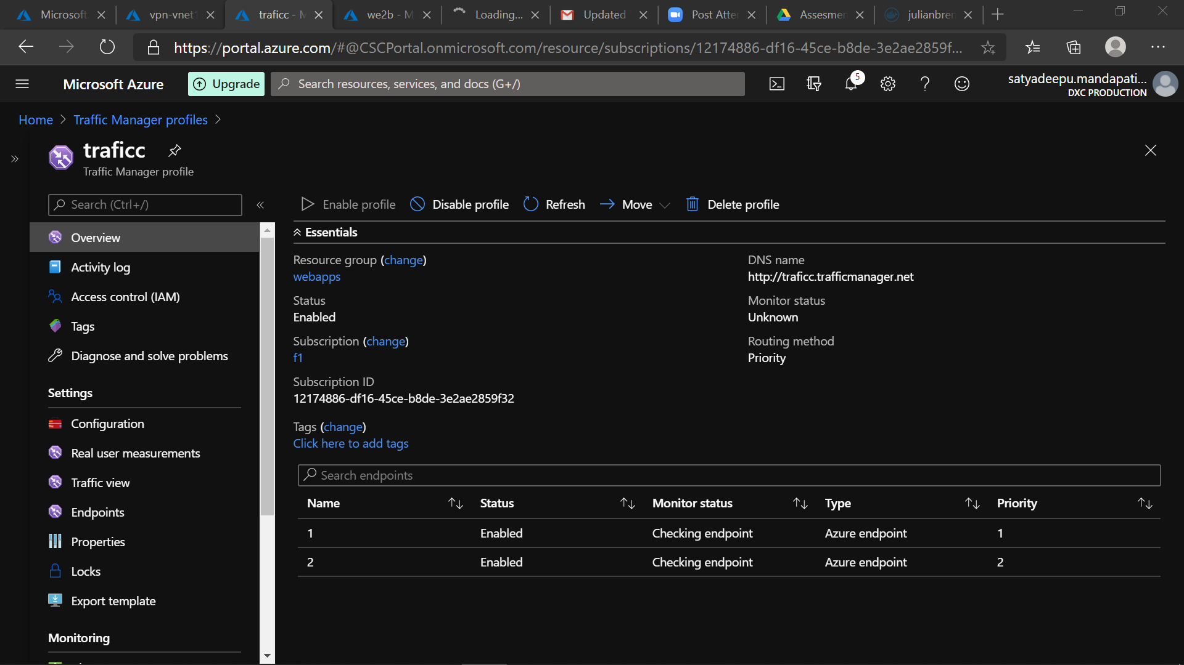

**3.create a windows server with AD installed and integrate with Azure AD**

* A Active Directory(AD) Role is Assigned to a Server in order to maintain and access the on premises networks

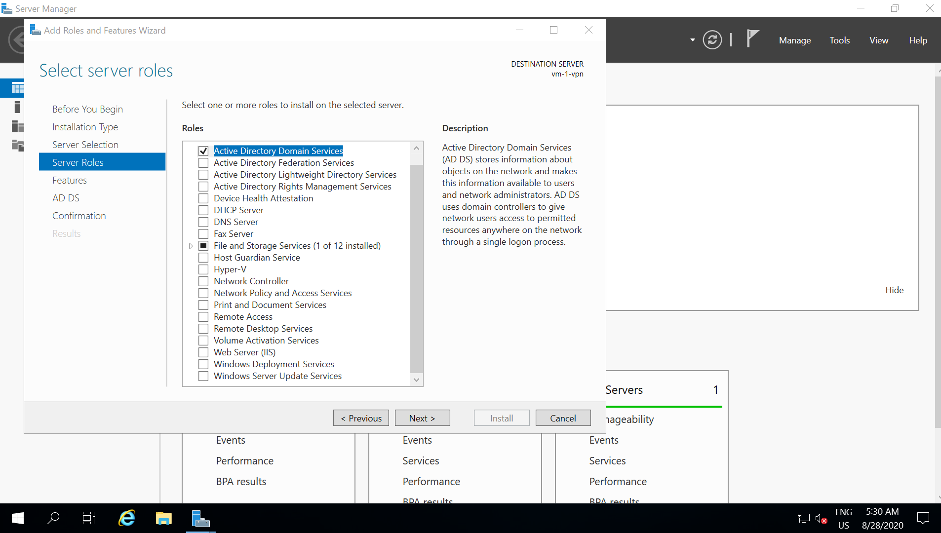

* Installing the Active Directory services in the Server

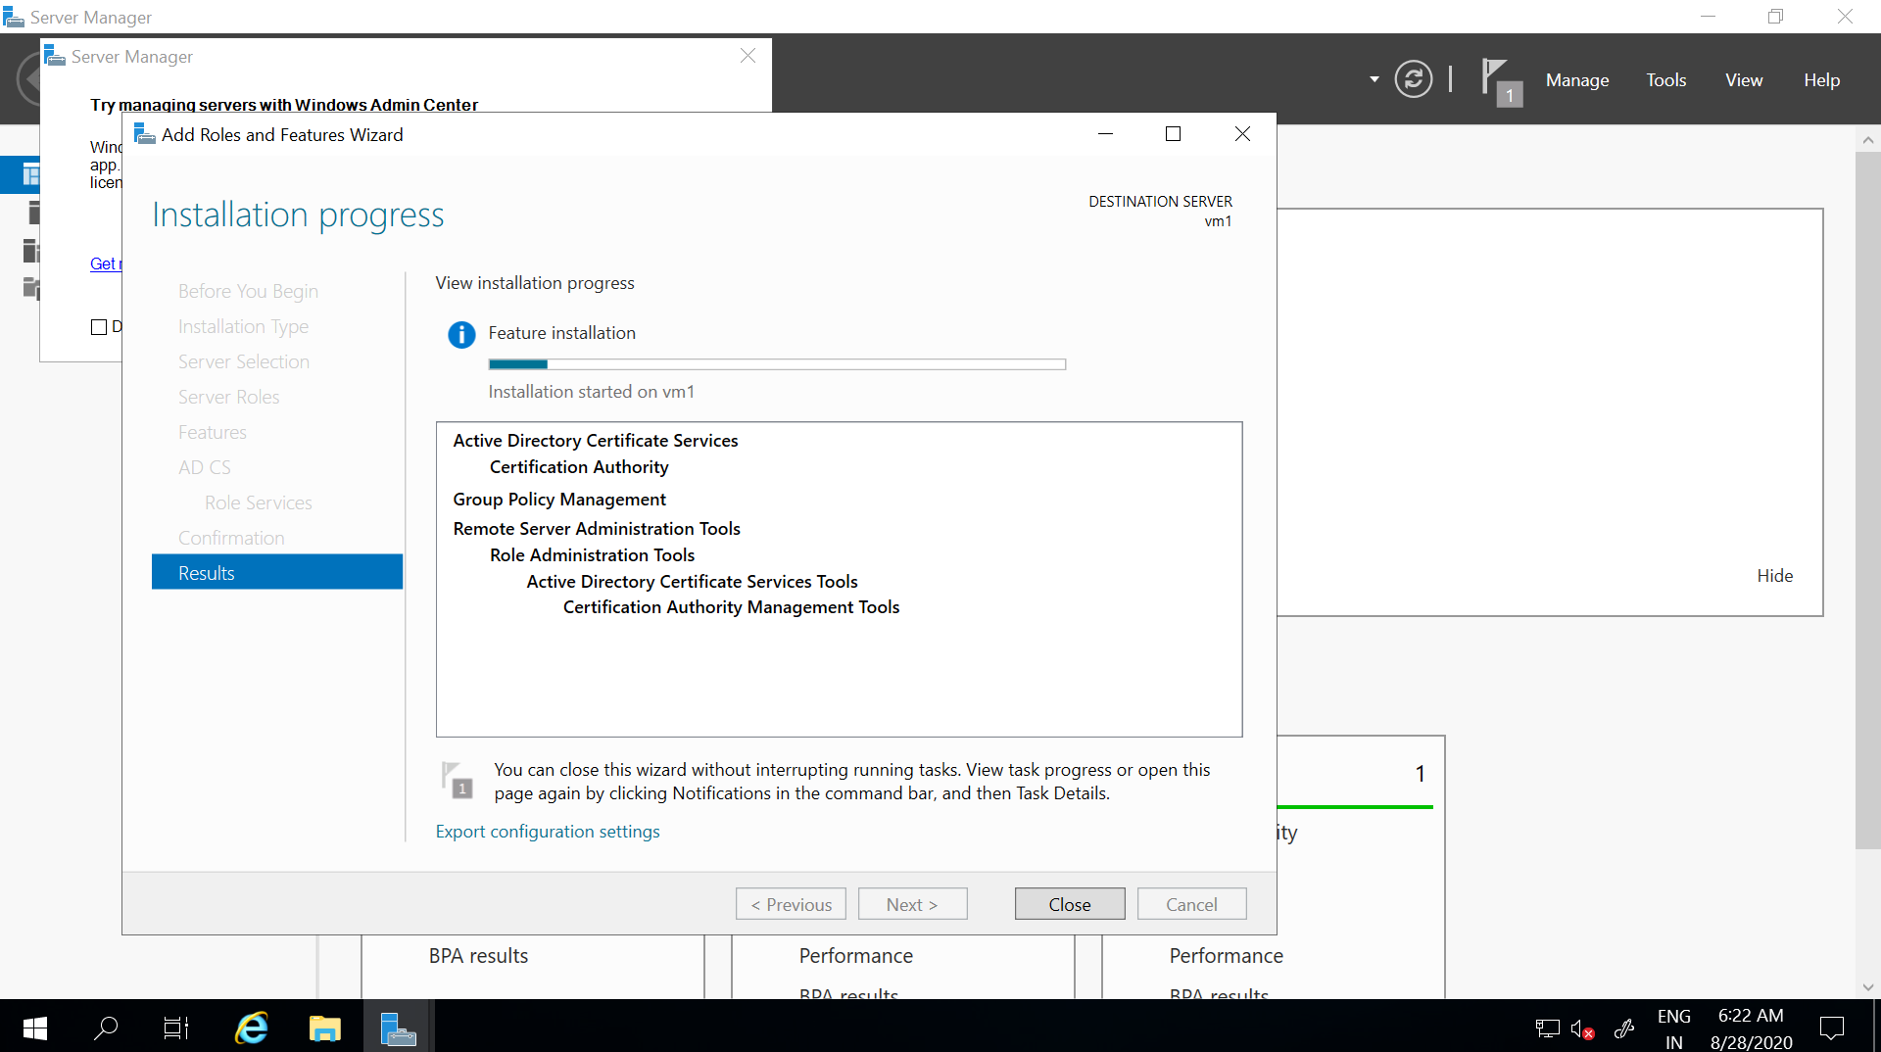

* Configuring directory services to Azure AD Connect

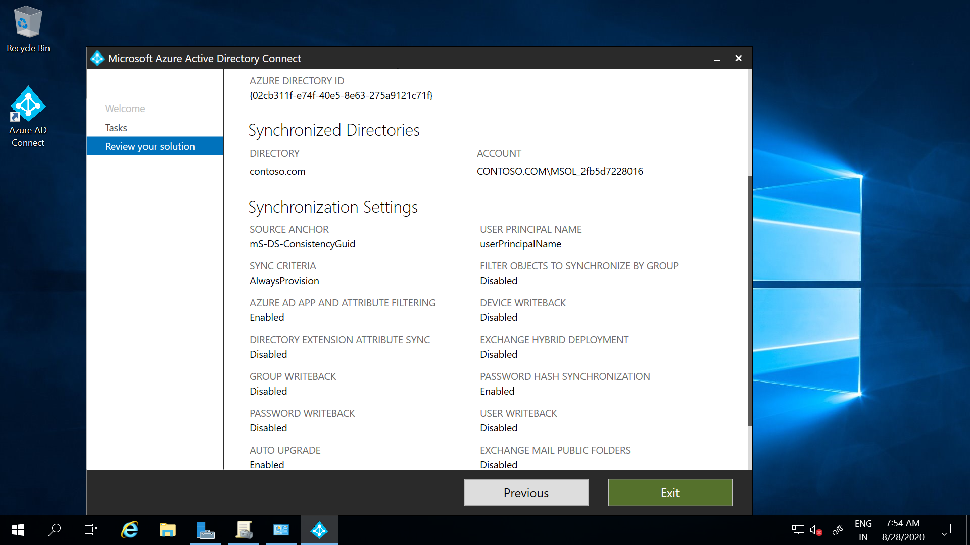

* On premises Active Directory is synced to Azure Active Directory

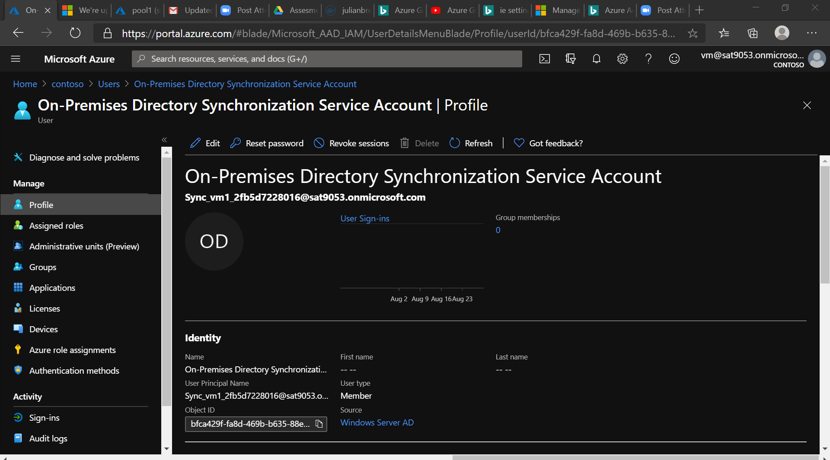

**4.configure a backup to the VM you installed AD**

* Backing up the Existing AD installed vm(vm-1-vpn) in to a Recover vault

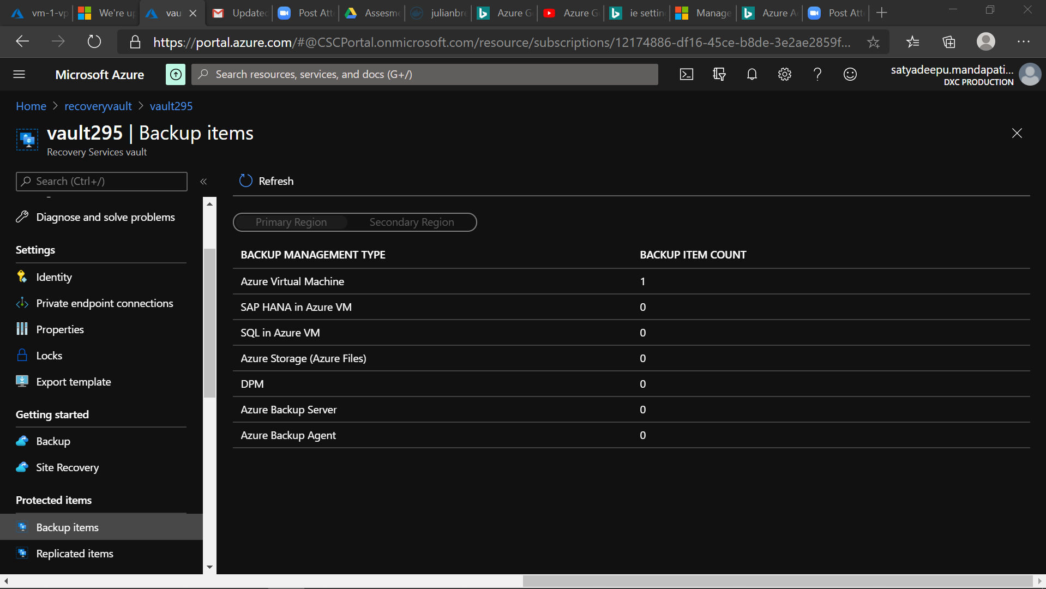

* Backup configured in vault

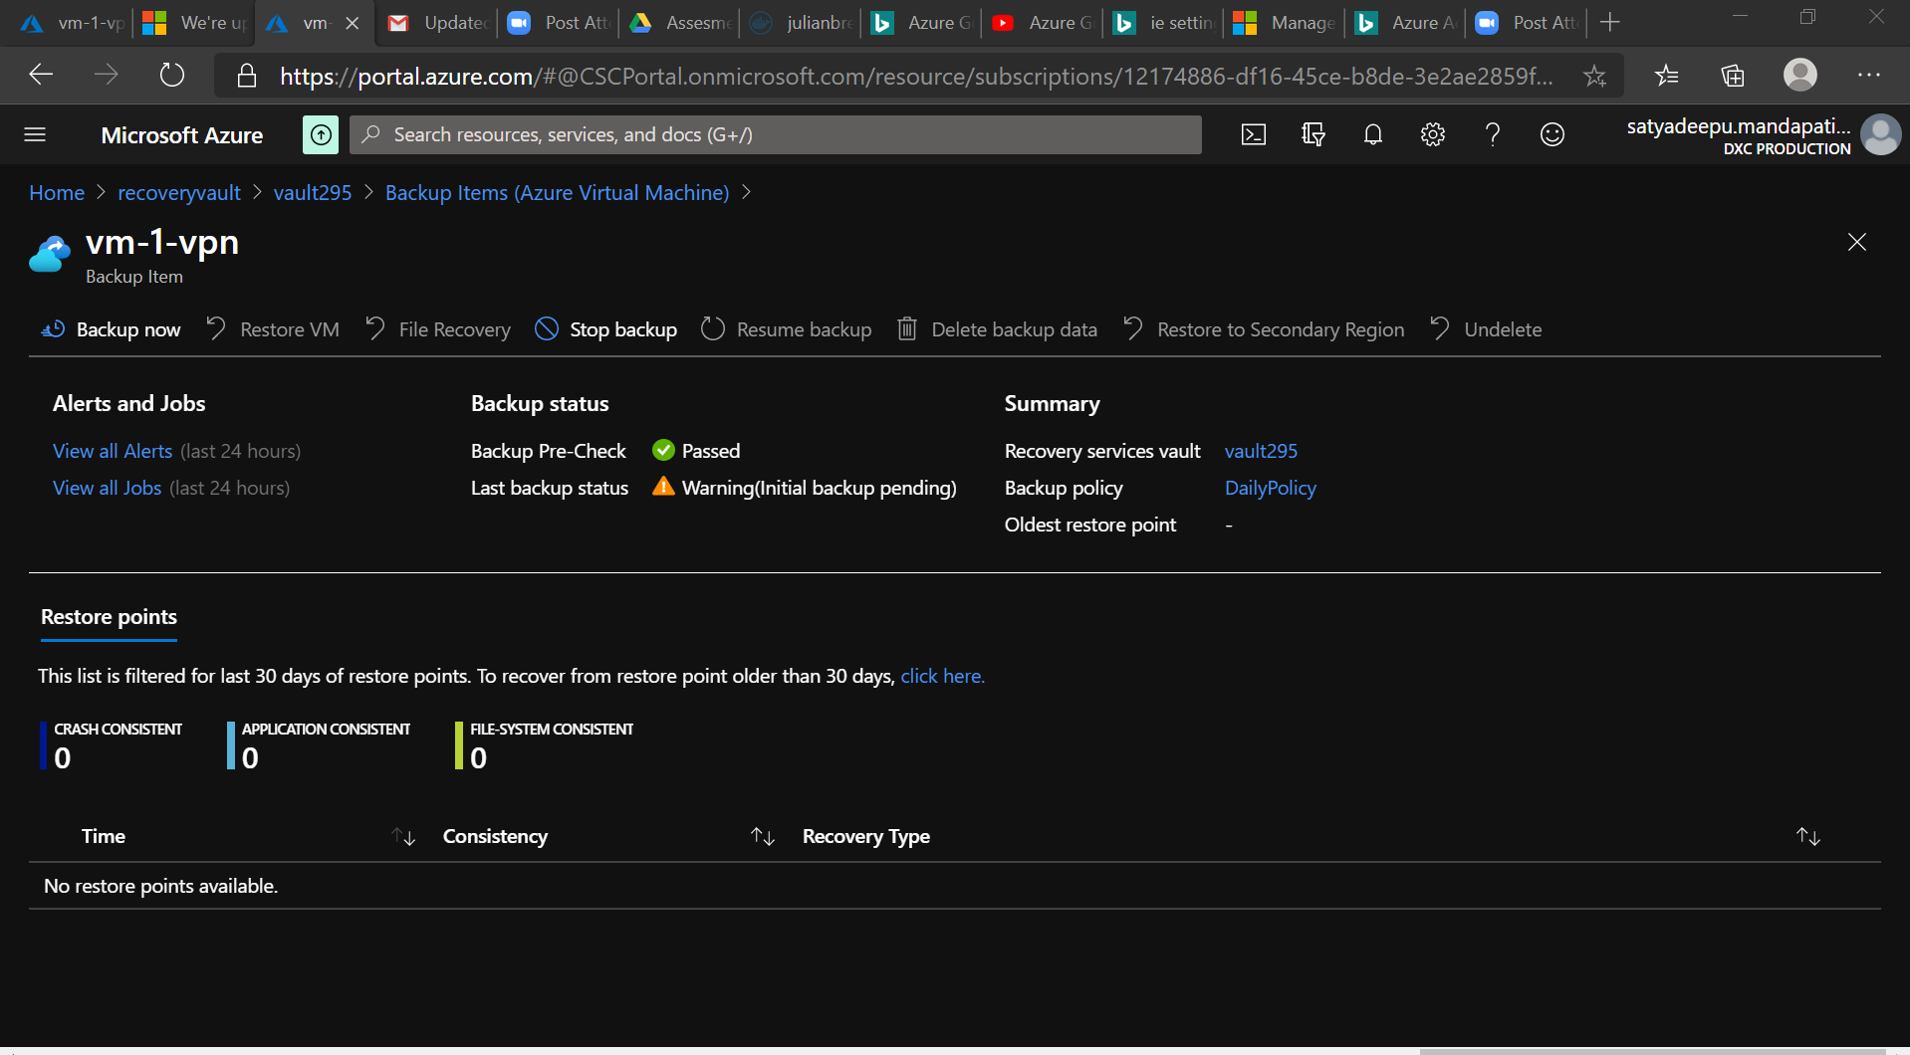

**5.configure alerts for the VM:**

* Configuring alerts For the Virtual machine

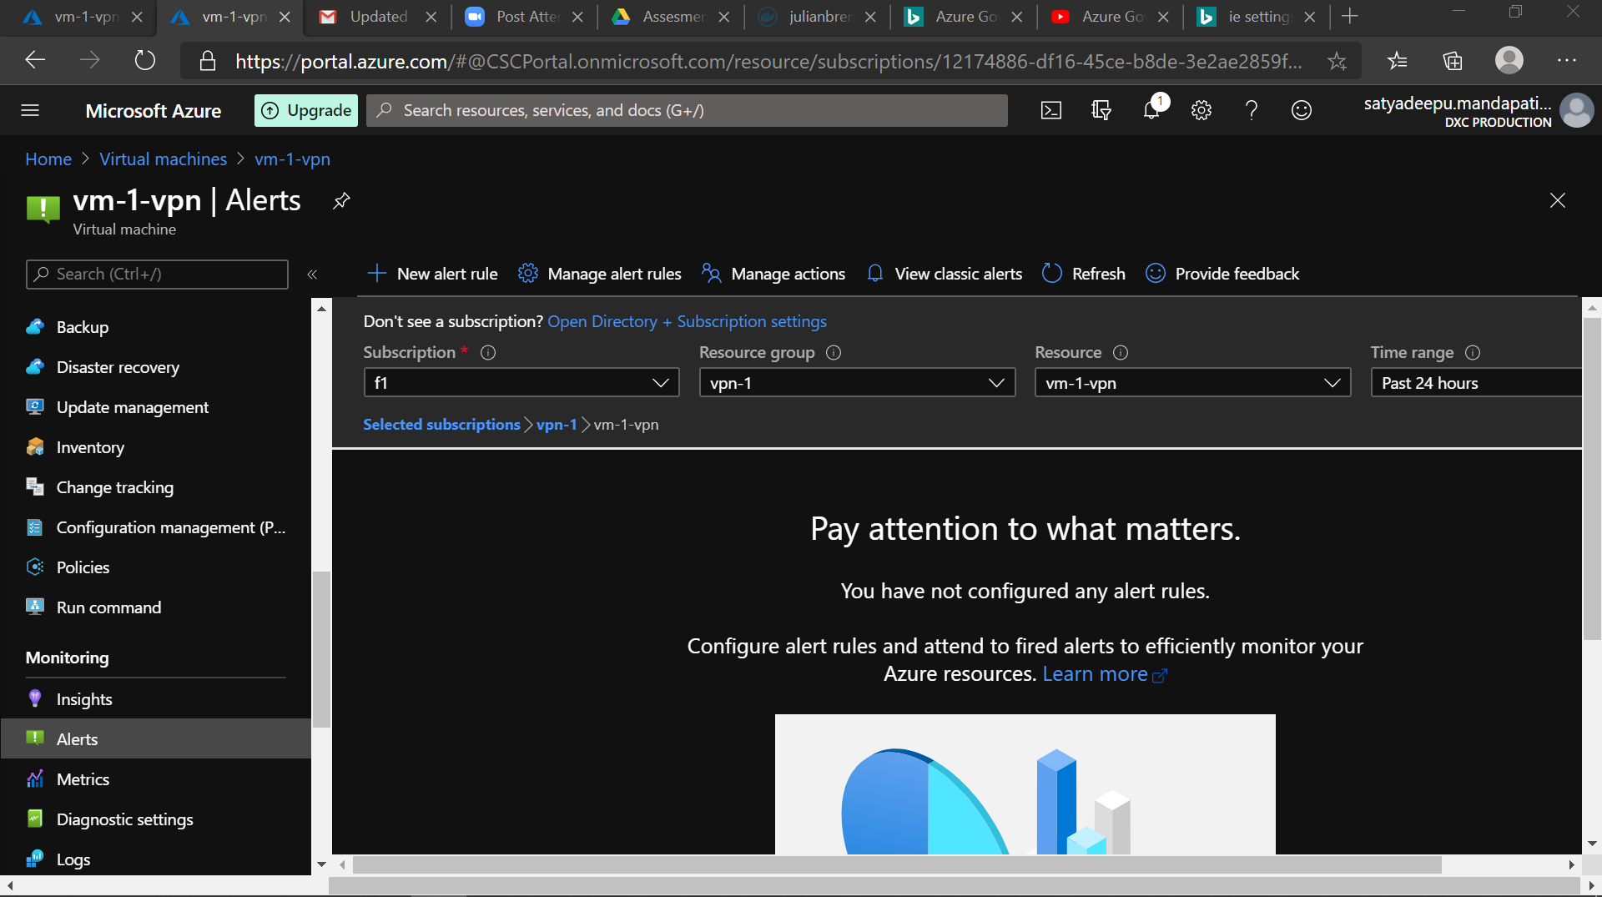

* A new Alert Rule is to be created for the Virtual Machine with an Alert condition logic.
* Here the Alert is created for **inbound Traffic flows** for the vm

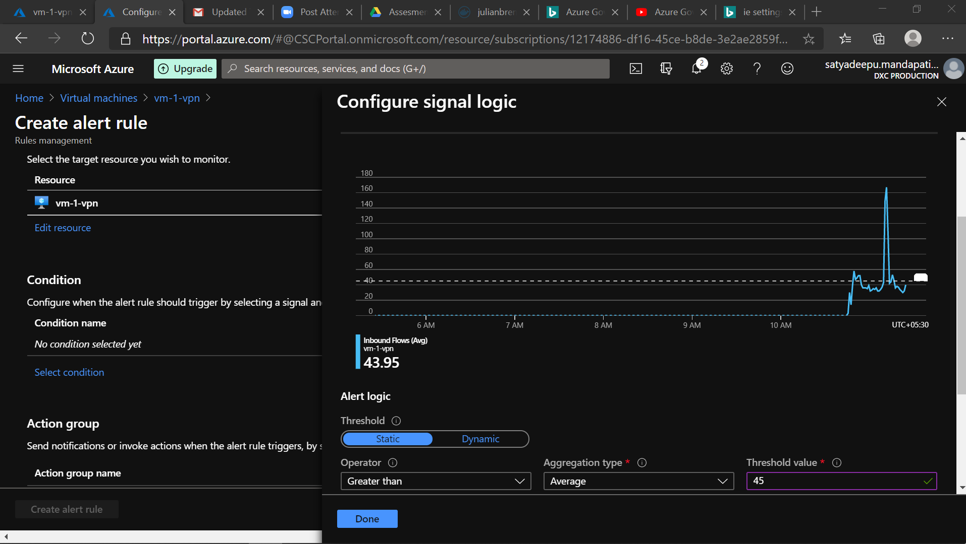

* Created an action group to receive the alerts

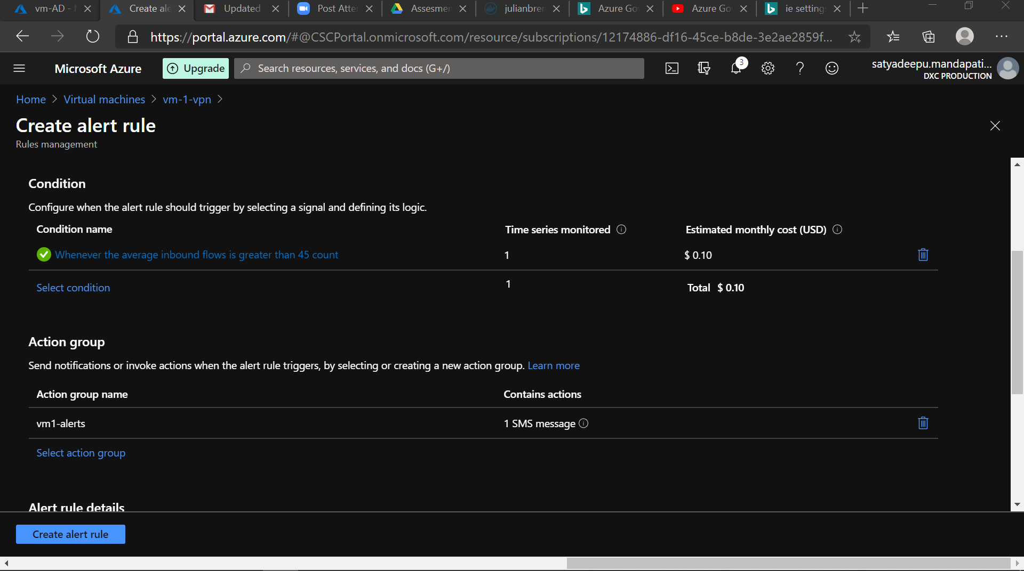

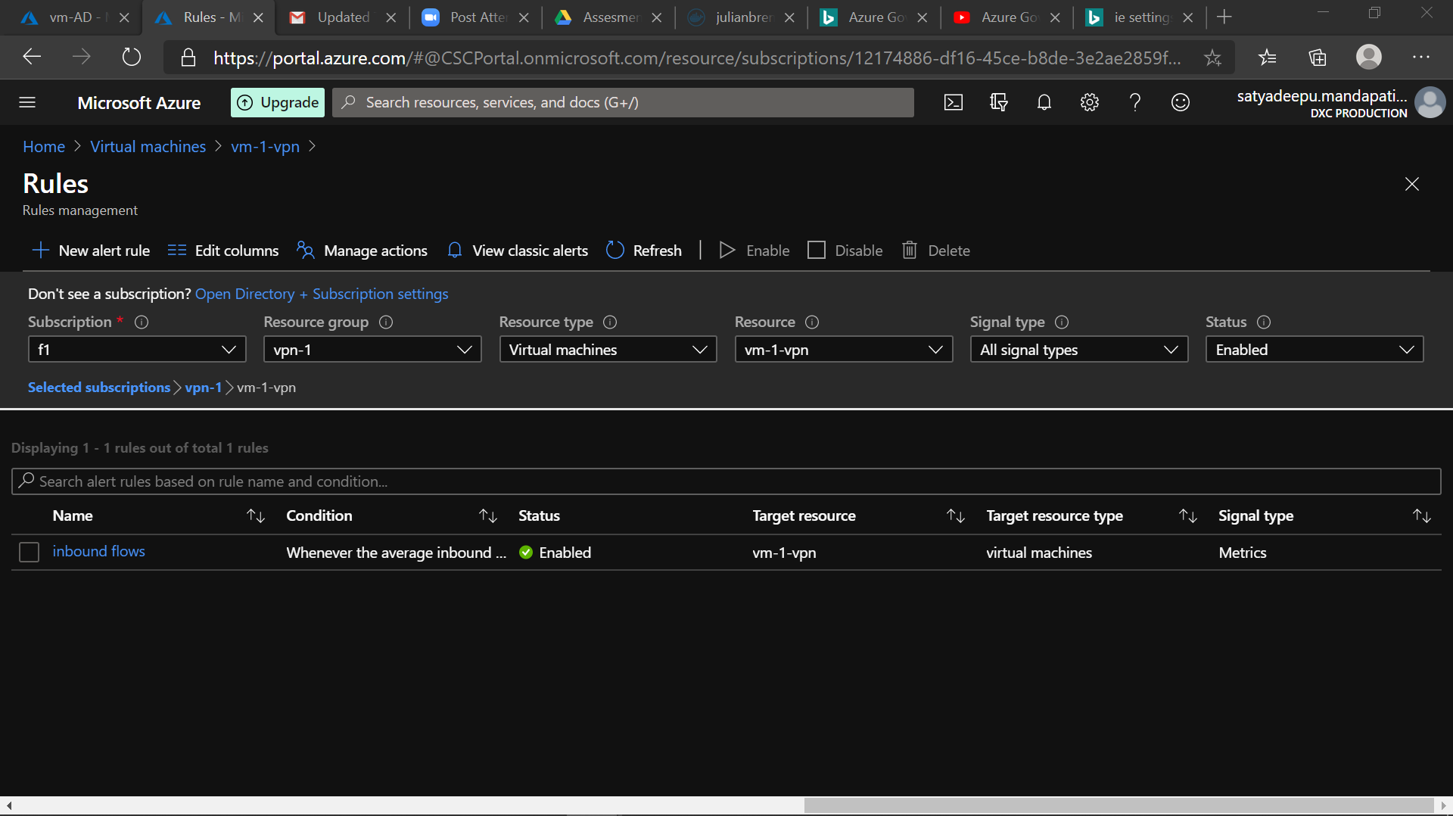

**6.Apply any security policy to the subscription**

* To apply the security policy we need to access the **security center** in azure and specify the subscription
* A custom Initiative is to be added
* Creating a initiative definition:

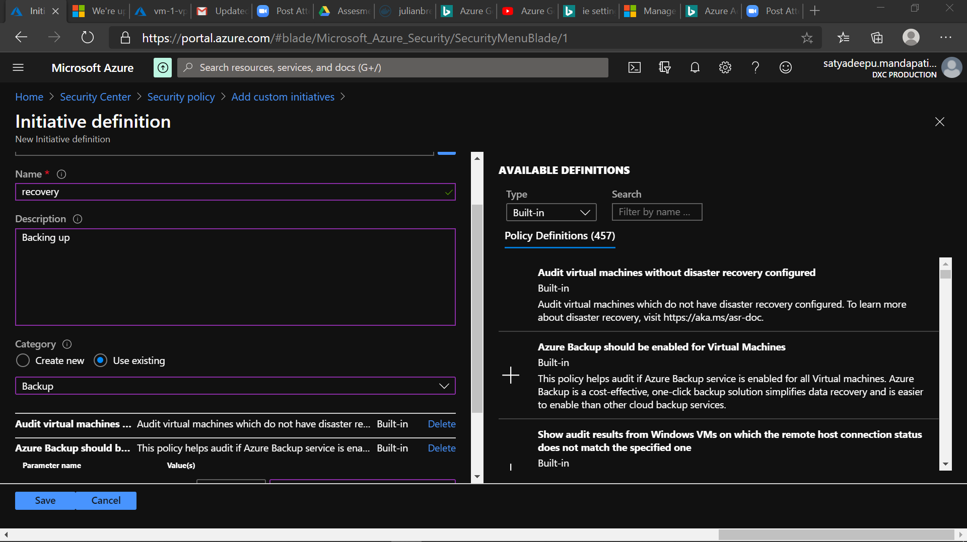

* Adding a custom Initiative:

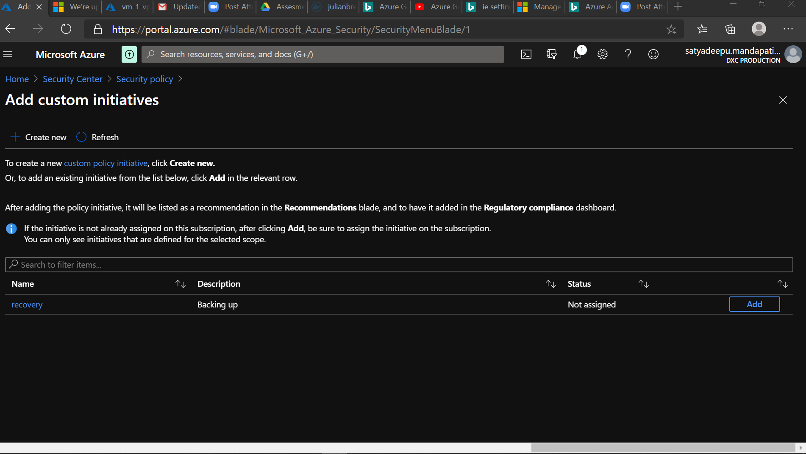

* Security policy is Attached to the Subscription:

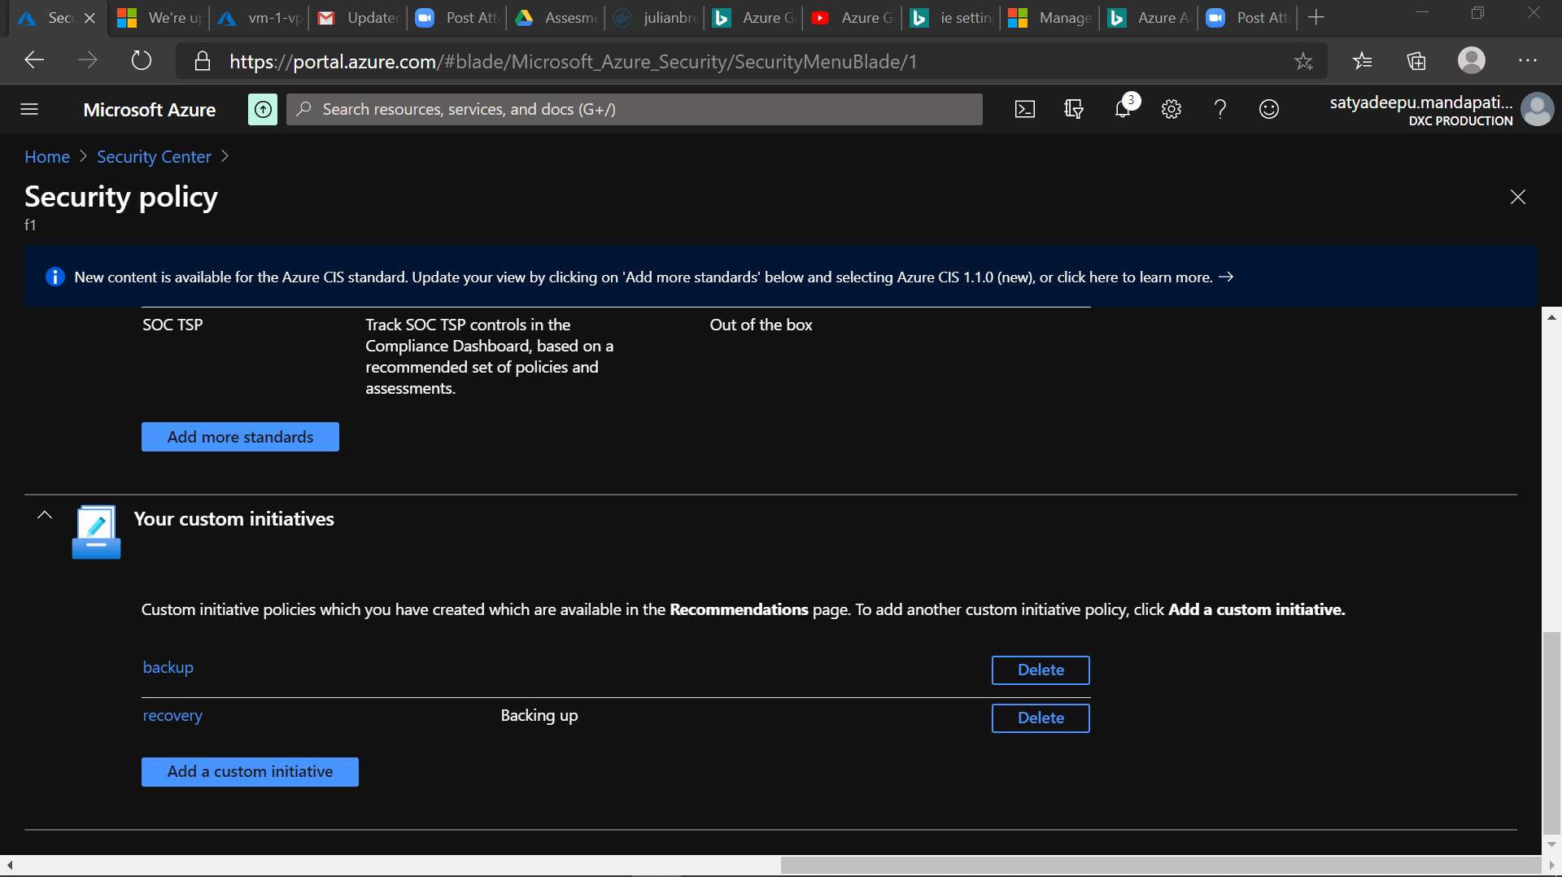

**7.create a SQL server with database installed in the elastic pool**

**> SQL Server Database**

* In order to create a SQL database we need a SQL Server up and running

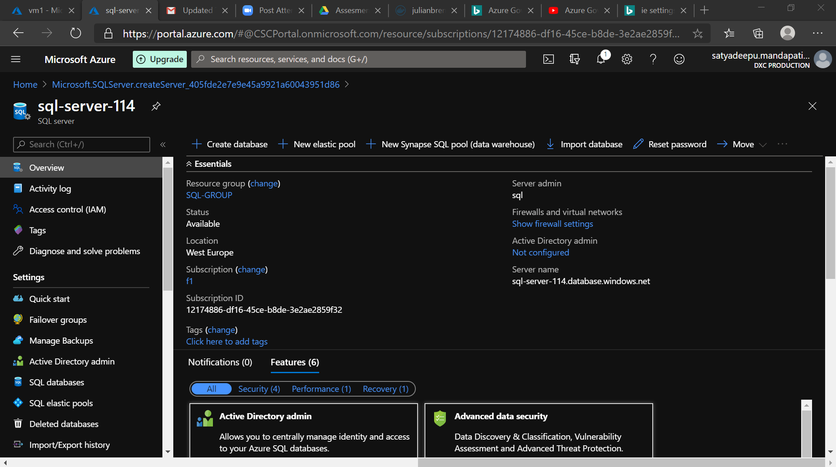

* Once the SQL Server is created we can create SQL Database in the server

